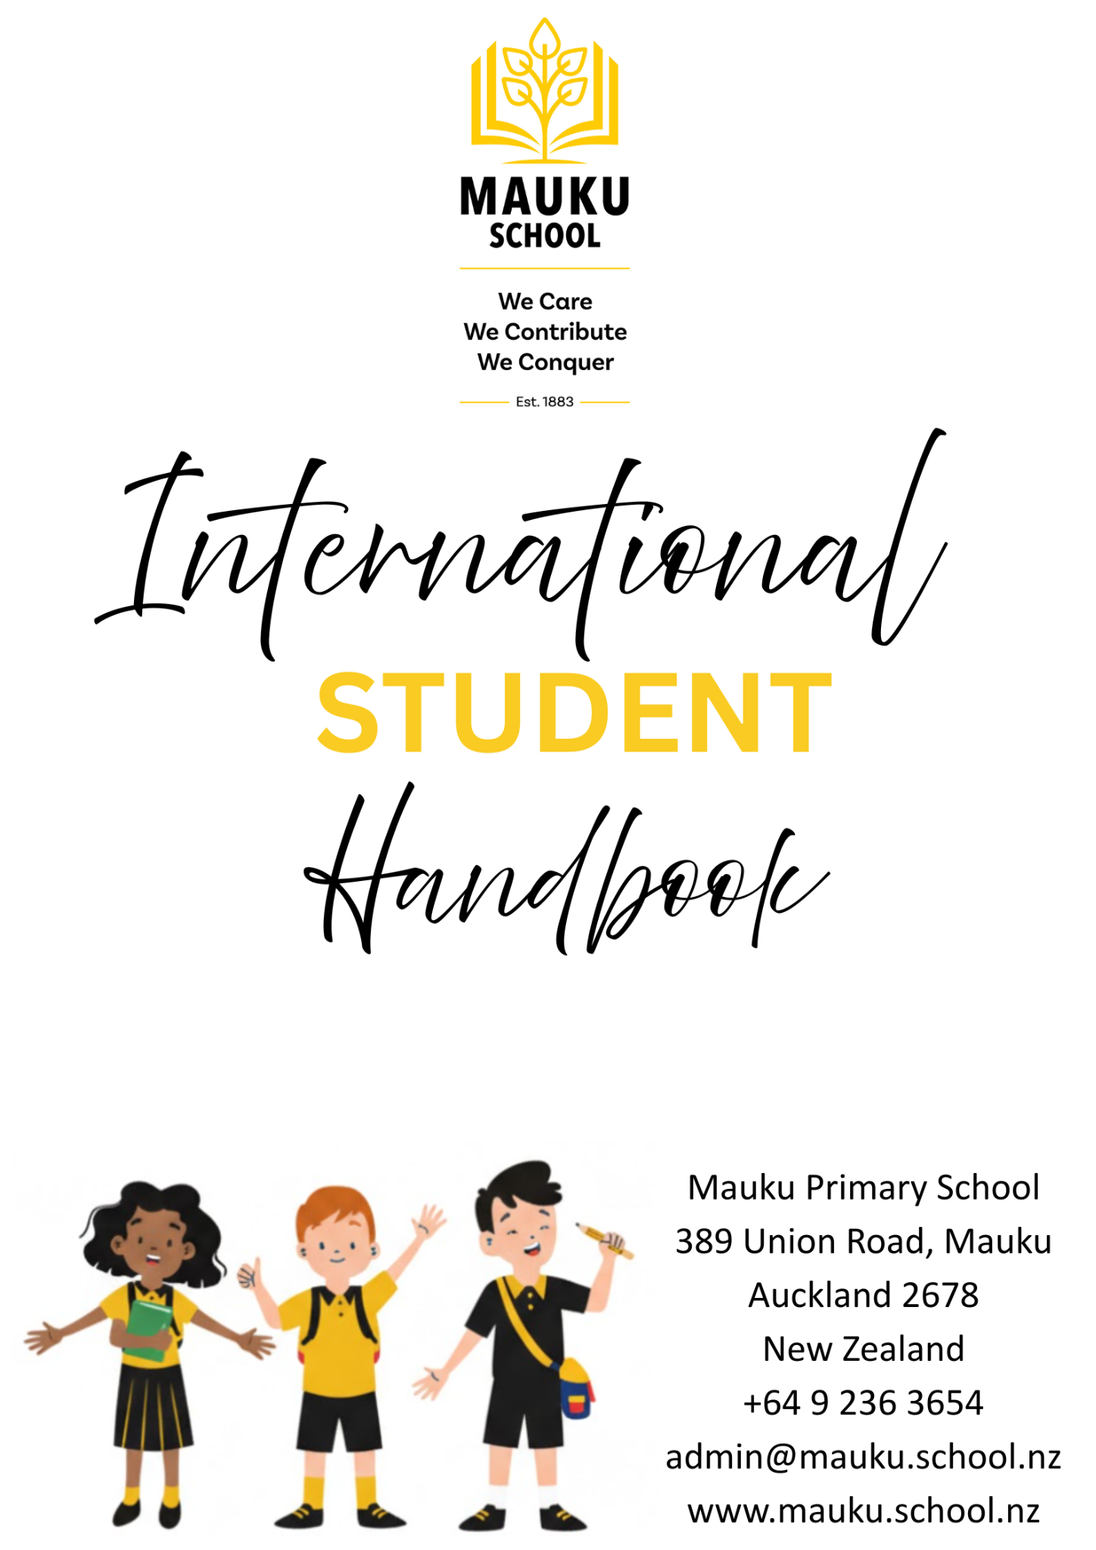

International Student Handbook
Contents

Mission Statement  Strategic Goals | 3
Welcome from the Principal  Key Staff | 4
School Location and Transport  Local Information and Emergency Contacts  Cultural Support and Inclusion | 5
Education (Pastoral Care of Tertiary and International Learners) Code of Practice 2021 | 6
Contract of Enrolment  International Student Programme | 7
Co-curricular and Extra Opportunities | 8
Stationery, Uniform, and Other Resources  Fees and Additional Costs  Communication with Families | 9
Digital Safety and Online Learning  Absences  Appointments | 10
Health, Safety, and Wellbeing  Medical Care and Consent  Emergency and Critical Incidents | 11
Protection of Fees Paid in Advance  Summary of Fee Refund Policy  Withdrawal and Ending Enrolment  Student Support | 12
International Student Complaints and Concerns  Internal Complaints Process | 13
External Complaints  Insurance Requirements  Health Services and ACC | 14
Visa Requirements  Before You Arrive | 15
Orientation Programme  Accommodation and Living Arrangements | 16
Appendix - International Student Fee Refund Policy | 17

Mission Statement

If we care for ourselves, others and our environment
Then we contribute to our world
And together we conquer our challenges and achieve our dreams

Strategic Goals

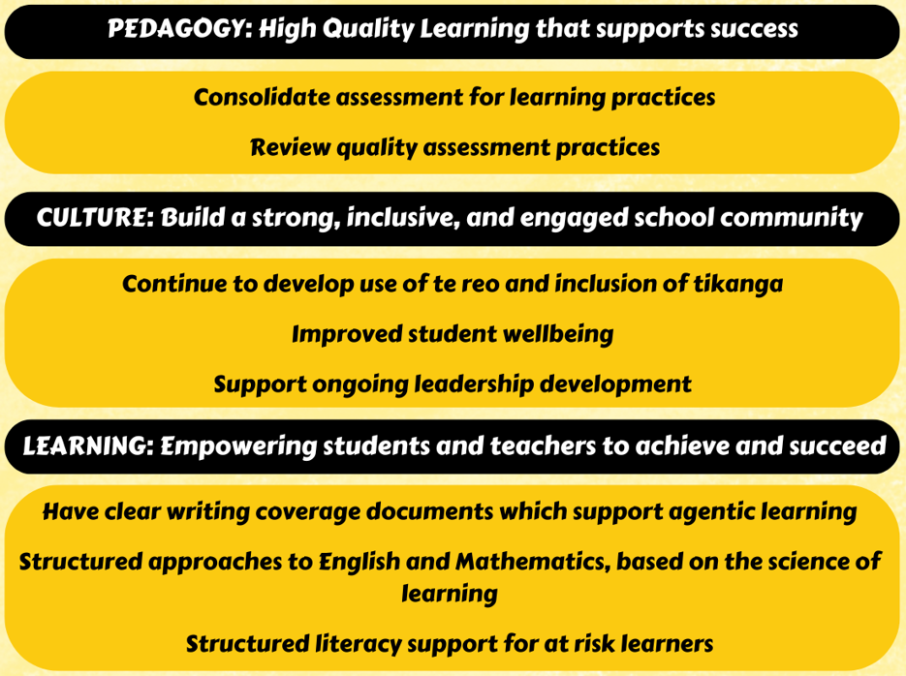

Welcome from the Principal
Kia ora, and a very warm welcome to Mauku School.

On behalf of our staff and students, we are truly delighted that your family has joined our incredible learning community.

Choosing Mauku School means choosing an authentic New Zealand primary school experience. We are a vibrant and creative school situated close to Pukekohe. This location offers a peaceful learning environment, providing an unforgettable taste of Kiwi life, while being conveniently located only about 35 minutes from Auckland International Airport, making your travels straightforward.

We are a well-resourced school with a dedication to ensuring your child enjoys the very best learning experiences. Our staff is an exceptional team of passionate teachers and support staff who go above and beyond for our students. They provide high-quality teaching and experiences where children can be confident, eager to collaborate, and engaged in learning. Your child will be welcomed by our friendly children and will join a supportive community with a strong sense of partnership with our parents.

We are confident that Mauku School will provide a truly memorable, enriching, and unforgettable chapter in your child's educational journey. We look forward to getting to know your family and welcoming you into the Mauku whānau (family).

James Christie
Principal

Key Staff

 |  | 
Shane Keown  Deputy Principal / International Student Director / 24/7 Contact  022 044 2322  shane@mauku.school.nz | Chantelle O’Callaghan  Executive Officer / Pastoral Care Coordinator  chantelle@mauku.school.nz | Janine Taylor  Office Manager / Enrolment Officer  janine@mauku.school.nz

The Person Responsible for International Students is the Deputy Principal / International Student Director, who is the main point of contact for all international student matters.

School Location and Transport

 | Mauku School is nestled amidst the picturesque paddocks and pastures of the Franklin District, offering a serene, country-like setting.  We are approximately 35 minutes drive from the Auckland International Airport (AKL), ensuring a straightforward and stress-free arrival for international students and their families.  Locally, we are just 10 minutes drive from Pukekohe, a thriving community hub. Pukekohe provides all necessary amenities, including excellent shopping, a variety of cafes and restaurants, healthcare services, and local entertainment. Our close proximity to Pukekohe High School is especially convenient for families who have older siblings enrolled in their international student programme.  For student transport, Mauku School operates a dedicated school bus service for the local area. Detailed route and schedule information will be provided upon enrolment. Alternatively, families are welcome to drive their children to school.

Local Information and Emergency Contacts

To support your time in New Zealand, it is helpful to be aware of local services and emergency contacts.
- Emergency services (Police, Fire, Ambulance): Dial 111
- Local medical centres and healthcare services are available in nearby Pukekohe
- Pharmacies, supermarkets, and other essential services are also located in Pukekohe
Families are encouraged to ensure they know how to access these services if needed.
Cultural Support and Inclusion

Mauku School values diversity and celebrates the different cultures within our school community.

Families are encouraged to ensure they know how to access these services if needed.
We support international students to share their culture and learn about New Zealand culture, including Māori language and customs.

Students are encouraged to participate fully in school life, and staff work to ensure all students feel included, respected, and valued.

School Day and Bell Times

Our daily schedule for students across Years 0 to 6 is structured to maximise learning and wellbeing.
7:50 Bus students arrive / Breakfast Club
8:15 Drop-off for non-bus students
8:45 School starts
9:50 – 10:00 Brain Food Break
11:00 – 11:30 Morning Tea Break
12:50 – 1:20 Lunch Break
2:35 Bus students leave
2:45 End of School (Pick-up for all non-bus students)

We hold school assemblies twice a week at 9:00 on Monday and Friday mornings.
On your child's first day, they will be formally welcomed to our school community with a traditional Māori greeting, a mihi whakatau. This special ceremony is a wonderful way to introduce new students.
Term Dates

2026
Term 1: Monday, February 4 – Thursday, April 2
Term 2: Monday, April 20 – Friday, July 3
Term 3: Monday, July 20 – Friday, September 25
Term 4: Monday, October 12 – Wednesday, December 16

About the Education (Pastoral Care of Tertiary and International Learners) Code of Practice 2021

Mauku School is a signatory to the Education (Pastoral Care of Tertiary and International Learners) Code of Practice 2021.
The Code is a framework that ensures international students are well informed, safe, and properly supported during their time studying in New Zealand. It sets out the standards that schools must meet to provide high-quality care and support for international students.
At Mauku School, we are committed to meeting and maintaining these standards. This includes supporting students’ wellbeing, providing clear information, and ensuring that all students have access to fair and transparent processes if they need support or wish to raise a concern.
You can find more information about the Code here: https://www2.nzqa.govt.nz/tertiary/the-code/

Contract of Enrolment

All international students must have a signed Contract of Enrolment before beginning their studies at Mauku School.

This contract outlines the terms and conditions of enrolment, including fees, refund conditions, and the responsibilities of both the school and the student’s parent(s) or legal guardian.

Families are required to read and agree to this contract as part of the enrolment process.

International Student Programme

Our programme at Mauku School is designed to ensure a welcoming, supportive, and academically rich experience for every international student. We focus on seamless integration into school life while providing targeted language assistance.
Students will be placed in a class with students of the same age to ensure full immersion and social integration. We offer a balanced and comprehensive New Zealand curriculum, covering Mathematics, Reading, Writing, The Arts, Social Sciences, Health and Physical Education, and Science. Our experienced teachers consistently adapt programmes and learning activities to meet individual student needs, actively supporting strong academic achievement and smooth learning progress.
To help your child settle in quickly and confidently, every new international student will be paired with a friendly student buddy to assist with daily routines, activities, and all Education Outside the Classroom (EOTC) opportunities. Our International Student Manager oversees the buddy. In addition, for long-term students, our ESOL staff provide focused support and targeted language learning to accelerate English proficiency. Our dedicated team works together to ensure your child receives the highest level of care and an integrated learning experience at Mauku School.
English Language Support and Academic Progress
At Mauku School, we recognise that international students may be learning in English as an additional language.
Teachers adapt classroom programmes to support each student’s level of English, and additional ESOL (English for Speakers of Other Languages) support is provided where needed.
Students’ progress is monitored regularly, and families will be kept informed of both academic progress and English language development through school reports and communication with teachers.
If a student requires additional support, this will be discussed with the family, and appropriate strategies will be put in place to help them succeed.

Co-curricular and Extra Opportunities

Mauku School is proud to offer a wide range of engaging extra-curricular activities and learning opportunities designed to enrich your child's experience here. Students can explore interests like environmental care by joining the Bee Club or the dedicated Enviro School group. For those interested in cultural expression, we have opportunities for involvement in both Kapa Haka and Pasifika performance groups, as well as a popular drumming program. If your child is interested in participating in any of these activities, they simply need to ask their classroom teacher about the sign-up process.

As a core part of our program, we also schedule regular Education Outside the Classroom (EOTC) experiences, which are integrated into the school calendar, and it's possible these exciting trips may occur during your visit period. We are actively involved in regular sporting events, and in winter, we offer a netball team specifically for our Senior girls. In addition to our regular school program, we always arrange for our international students to enjoy a special visit to a local farm to experience a unique part of New Zealand life.

Participation in activities will depend on availability, student interest, and in some cases, additional costs.

School Rules
At Mauku School, we aim to create a safe, respectful, and positive learning environment.
Our core principle is simple: We respect, help, and support each other. Courtesy and respect must be shown to all students and staff at all times.
For safety, students are not to leave the school grounds unless accompanied by an authorised adult. The Staffroom and classrooms during break times (unless it's raining) are out of bounds. For sun safety, hats must be worn outside during Terms 1 and 4.
Only the Mauku School uniform is to be worn. Upon arrival, students must complete a cyber safety agreement. Mobile phones are handed in to the school office upon arrival and collected at the end of the day.
Student Rights and Responsibilities
International students have the right to:
- Feel safe and supported at school
- Be treated with respect and fairness
- Receive appropriate academic support
- Raise concerns or complaints without fear
Students are expected to:
- Follow school rules and expectations
- Attend school regularly and on time
- Respect others

Stationery, Uniform, and Other Resources
All essential resources your child needs for their time at Mauku School will be provided, with the costs included in our fees. This ensures a straightforward start for your family. We supply all necessary stationery and classroom materials. Senior students will also be provided with a Chromebook to use for their learning while they are enrolled with us. Please note that families are responsible for supplying their child's daily lunch.
Our school uniform consists of a polo shirt and black shorts. We also offer school jerseys, and students require school hats in terms 1 and 4. All uniform items are supplied by the school. Short-term students are required to return these at the completion of their stay, or they can be purchased through the office. Long-term students may keep their uniform.
Fees and Additional Costs
Tuition fees at Mauku School include access to classroom learning, stationery, and essential resources.
There may be some additional costs during your child’s time at school, such as:
- School trips or Education Outside the Classroom (EOTC) activities
- Optional co-curricular activities
- Personal items such as lunches and personal equipment
Any additional costs will be clearly communicated to families in advance.
Communication with Families
At Mauku School, we communicate in a number of ways…
Email: Teachers or the office staff will use this to contact you or to communicate information with you. The email address for teachers is commonly the person’s name followed by @mauku.school.nz (for example, shane@mauku.school.nz). Our office email address is admin@mauku.school.nz
School Newsletters: These are emailed.
Facebook: We have a closed Facebook page where we share information and celebrate the awesome things that happen at Mauku School. Search for Mauku School, request to join and answer the security questions.
Seesaw: This is an app which teachers use to share students' learning. You receive a notification when work is posted to this platform.
Skool Loop: This is an app that allows us to send you notifications or permission forms. Our newsletter and calendar are on this app too. You can also let us know about absences through this app.
Phone: The office is available for you to get in touch with us on 09 236 3654.
Digital Safety and Online Learning
Mauku School uses digital tools and online platforms to support student learning.
All students are expected to use digital devices safely and responsibly. As part of enrolment, students will complete a cyber safety agreement outlining appropriate use of technology.
The school takes online safety seriously and monitors the use of digital platforms to ensure a safe learning environment.
Parents and caregivers are encouraged to support safe use of technology at home.
Absences
We understand that occasionally you may need to miss school due to illness or other unavoidable reasons. If you are going to be absent, it is important that your parents or caregivers notify the school before 8:45 AM on the day of the absence.
There are four easy ways to let us know:
- You can call the school office directly.
- You can email our administration team at admin@mauku.school.nz.
- A text message can be sent to 021 123 0481.
- Alternatively, you can use the Skool Loop app to submit an absence notification.
Regular attendance is important for student wellbeing, academic progress and visa requirements.
Mauku School monitors student attendance daily. If a student is absent without explanation, the school will contact the student’s parent or legal guardian.
Appointments

If you have an important appointment, such as a visit to a doctor, dentist, or any other appointment, that requires you to miss class, you must notify the office or the International Student Director in advance. Provide them with written proof of the appointment, such as a card or email, so your absence can be recorded as authorised.
Medication

If you require any medication to be administered during school hours, a specific medication form must be completed first. These forms are available from the office. The office will then keep your medication securely in a locked cupboard for dispensing as needed and according to the instructions on the form.

Health, Safety, and Wellbeing

The health, safety, and wellbeing of our international students is a priority at Mauku School.

If a student becomes unwell or is injured during the school day, the school will provide appropriate first aid and contact parents or caregivers as required. In more serious situations, emergency services will be contacted.

The school will work with families to ensure that students have access to appropriate medical care while in New Zealand.

Students are encouraged to speak to their teacher or a member of staff if they are feeling worried, unwell, or need support. Our staff are committed to creating a safe and supportive environment where students feel comfortable asking for help.

Medical Care and Consent

Parents or legal guardians are required to provide medical information and emergency contact details as part of the enrolment process.

By enrolling at Mauku School, parents give permission for the school to:
- Seek medical treatment in the event of illness or injury
- Act in the best interests of the student in an emergency
- Include students in supervised school activities

Emergency and Critical Incidents

Mauku School has procedures in place to respond to emergencies and critical incidents, including accidents, natural disasters, and lockdown situations.

In the event of a serious incident, the school will:
- Take immediate steps to ensure student safety
- Contact parents or caregivers as soon as possible
- Work with relevant emergency services where required

We are committed to ensuring clear communication and ongoing support for students and families during any such event.

24/7 Emergency Contact
Mauku School provides a 24/7 emergency contact for international students and their families.
In the event of an emergency outside of school hours, please contact Shane Keown (Person Responsible for International Students) : 022 044 2322.
This number is available at all times for urgent matters relating to student safety and wellbeing.
Protection of Fees Paid in Advance

Mauku School has processes in place to ensure that international student fees paid in advance are protected.

Fees are receipted and recorded through the school’s financial systems and managed in accordance with school policies and procedures.

In the event that a student withdraws or is unable to continue their enrolment, any refund of fees will be managed in accordance with the school’s Refund Policy.

If the school is unable to continue to offer education to the student, the school will work with the student and their family to ensure appropriate arrangements are made, including any applicable refunds.

Fee Refund Policy
Full details of the school’s Refund Policy are provided at the end of this handbook.
All refunds are considered in accordance with the school’s policy and the Education (Pastoral Care of Tertiary and International Learners) Code of Practice 2021.
Withdrawal and Ending Enrolment
If a student withdraws from Mauku School, written notice must be provided by the parent or legal guardian.
The school may also end a student’s enrolment in serious situations, including breaches of school rules or behaviour expectations.
In all cases, the school will act fairly and in accordance with its policies, and any applicable refund of fees will be managed in line with the Refund Policy.
Student Support

At Mauku School, we are committed to ensuring every international student feels safe, supported, and included.

Students can seek support at any time from:
- Their classroom teacher
- The International Student Director
- School office staff

Students are encouraged to speak up if they have any concerns or need help. They may also choose to have a support person with them when discussing any concerns.

Raising a concern or complaint will not negatively affect the student’s enrolment or how they are treated at school.

International Student Complaints and Concerns

Internal Complaints Process
Students and their parents or legal guardians are encouraged to raise any concerns directly with the school in the first instance. This can be done by speaking with the classroom teacher or the Person Responsible for International Students.
The school will:
- Listen carefully to the concern
- Investigate the issue fairly
- Work towards a resolution as quickly as possible
- Keep a record of the complaint and the outcome
A Response | B Response | C Response
  Classroom/playground concern involving your child
  ↓
  Contact your child's teacher by email telephone, or face to face
  ↓
  Meet with the classroom teacher if required
  ↓
  Issue resolved.
  If issue is not resolved, move to
  B Response
  An unresolved classroom/playground concern, or school wide concern
  ↓
  Contact Management Team by email or phone
  ↓
  Meet with Management Team member if required
  ↓
  Issue resolved.
  If issue is not resolved, move to
  C Response
  Concern still not resolved or involves Principal or Board of Trustees
  ↓
  Becomes Formal Complaint
  ↓
  Written complaint posted or emailed to the Board of Trustees via chairperson outlining problem and including your name and contact details
  ↓
  The Board of Trustees will work to resolve the complaint and follow up within 4 weeks.
External Complaints Options
If a concern is not resolved through the school’s internal process, students and families can seek independent support.
For contractual or financial disputes, you can contact Study Complaints: https://www.studycomplaints.org.nz/
For concerns about the school’s compliance with the Education (Pastoral Care of Tertiary and International Learners) Code of Practice 2021, you can contact NZQA:
https://www2.nzqa.govt.nz/about-us/contact-us/complaint/
These services are independent and free of charge.
Students and families may have a support person present during any stage of the complaints process and can be assured that concerns will be treated respectfully, fairly, and confidentially where appropriate.
Insurance Requirements

All international students must have appropriate and current medical and travel insurance for the duration of their stay in New Zealand.

This insurance must cover:
- Medical care, including doctor visits, hospitalisation, and surgery
- Emergency dental treatment
- Repatriation or return to the student’s home country
- Travel disruptions and unexpected changes
- Costs for family travel in the case of serious illness or injury
- Death of the student, including repatriation

Students may arrange their own insurance, or the school can assist with organising a suitable policy. Proof of insurance must be provided before the student begins their studies.

Health Services and ACC

Most international students are not entitled to publicly funded health services while in New Zealand. If medical treatment is required, students and their families may be responsible for the full cost of care.

The Accident Compensation Corporation (ACC) provides accident insurance for all people in New Zealand. However, ACC does not cover all medical costs and does not replace the requirement for comprehensive medical and travel insurance.

Visa Requirements

All international students must hold a valid student visa for the duration of their study in New Zealand.

Short-term
Students from visa waiver countries are eligible for short-term visitors visa and may study for up to three months under this visa. To see if you are eligible for a short-term visitor visa, please visit Immigration New Zealand.

Long-term
You need a student visa if you want to study in New Zealand for more than 3 months.

All International Students, whether previously enrolled at another school or not, must obtain a student visa to attend Mauku School. A student visa is particular to that student and that school. Mauku School must be named on the student visa. If you are studying for more than twelve weeks, please apply for a student visa at least eight weeks before your departure date.

Passports
Passports of students and parents will be checked for immigration status and must be provided to Mauku School or our authorised Enrolment Officer as required. A photocopy of the passport and visa will also be taken prior to the commencement of any tuition.

Mauku School monitors visa status and records visa expiry dates. It is the responsibility of the student’s parent or legal guardian to ensure that the student’s visa remains valid at all times.

Before You Arrive

Before arriving in New Zealand, please ensure you have:
- A valid passport and visa
- Approved medical and travel insurance
- Signed your Contract of Enrolment
- Arranged accommodation with your parent(s) or legal guardian
- Prepared school uniform and personal items

Arrival and Orientation

We aim to make each student’s arrival and start at Mauku School as smooth and welcoming as possible.

On arrival, students and their families will be supported to ensure they feel confident and prepared for school life.

All new international students will take part in an orientation programme. This includes:
- Introduction to the school, staff, and daily routines
- Explanation of school expectations and rules
- Support with understanding classroom learning
- Meeting their student buddy
- Tour of the school and key facilities

Parents or caregivers are encouraged to attend orientation. This helps ensure they understand how the school operates and how best to support their child.

Students will continue to receive support during their first weeks to help them settle in and feel comfortable.

Accommodation and Living Arrangements
At Mauku School, all international students must live in accommodation that is safe, supportive, and appropriate for their age and needs.
Students enrolled at Mauku School live with their parent(s) or legal guardian while studying in New Zealand. Parents or legal guardians are responsible for the student’s day-to-day care, wellbeing, and supervision outside of school hours.
For students under the age of 10, living with a parent or legal guardian is a requirement under the Education (Pastoral Care of Tertiary and International Learners) Code of Practice 2021.
The school maintains regular communication with families to support student wellbeing and to ensure that living arrangements continue to meet the needs of the student.
Any changes to a student’s living arrangements must be discussed with and approved by the school in advance.
The school may request information about a student’s living arrangements at any time to ensure their safety and wellbeing.

Appendix

International Student Fee Refund Policy

Requests for a refund of international student fees
- The School will consider all requests for a refund of international student fees. Requests should be made in writing to the School as soon as possible after the circumstances leading to a request. All refunds will be settled under the terms of this policy unless otherwise agreed by the School.

- A request for a refund should provide the following information to the School:
- The name of the Student;
- The circumstances of the request;
- The amount of refund requested;
- The name of the person requesting the refund;
- The name of the person who paid the fees;
- The bank account details to receive any eligible refund including bank address and swift code where relevant; and
- Any relevant supporting documentation such as receipts or invoice.

Non-Refundable Fees
- The School is unable to refund some fees. The following fees relate to expenses that the School may have paid or will incur as a result of receiving an application for enrolment and cannot be refunded:
  - Administration Fee: Administration fees meet the cost of processing an international student application. Administration fees exist whether an application is accepted or not or whether a Student remains enrolled after an application is accepted.
  - Insurance: Once insurance is purchased, the School is unable to refund insurance premiums paid on behalf of a student. Students and Parents may apply directly to an insurance company for a refund of premiums paid.
  - Homestay Placement Fee: Homestay placement fees meet the cost of processing a request for Homestay accommodation by the student. Costs incurred for arranging Homestay accommodation for the Student prior to the refund request cannot be refunded.
  - Used Homestay Fees: Homestay fees paid for time the Student has already spent in a Homestay cannot be refunded. Used Homestay fees may also include a notice period of two weeks.
  - Portion of Unused Tuition Fees: The School may retain a portion of unused tuition fees. Amounts retained will relate to costs that have been incurred or committed by the School and may vary.

Requests for a refund for failure to obtain a study visa
- If the Student fails to obtain an appropriate visa, a refund of international student tuition fees will be provided less any non-refundable fee that has been paid. Evidence must be provided to the school of Immigration New Zealand declining to grant a visa.

Requests for a refund for enrolment of one term or less:
- Where the Student is enrolled for one term or less and withdraws early, either before or after the start date of enrolment, other than where they have failed to obtain an appropriate visa and have provided evidence of this, there will be no refund of tuition fees or other relevant non-refundable fees.

- Where the School terminates the enrolment of a Student enrolled for one term or less, there will be no refund of tuition fees, or other relevant non-refundable fees.

Requests for a refund for voluntary withdrawal from enrolment of more than one term:
- If the Student voluntarily withdraws 21 days or more before the start date of enrolment, a refund will be provided less any non-refundable fees as outlined in this policy. The 21 days will be counted from the day after the School receives written notice of the Student’s intention to withdraw from enrolment.

- If the Student voluntarily withdraws less than 21 days before the start date of enrolment, other than where they have failed to obtain an appropriate visa and have provided evidence of this, a refund will be provided less a minimum of 10 weeks’ tuition fees and any other relevant non-refundable fees as outlined in this policy. The 21 days will be counted from the day after the School receives written notice of the Student’s intention to withdraw from enrolment.

- If a Student voluntarily withdraws after enrolment has commenced, a minimum of 10 tuition weeks’ notice is required. The notice period will begin the day after the School receives written notice of the Student’s intention to withdraw from enrolment and the student may continue to attend school during the notice period. The notice period does not include weeks that fall during scheduled school holidays. In the event that less than 10 weeks’ notice is given, refunds may be calculated based on the refund that would have been due if the termination had taken place 10 weeks after notice was given.

Requests for a refund where the School fails to provide a course, ceases as a signatory, or ceases to be a provider:

- If the School fails to provide the agreed course of education or is no longer a signatory to the Code or no longer operates as an international education provider, the School will negotiate with the Student or their family to either:

  - Refund the unused portion of international student tuition fees or other fees paid for services not delivered, or
  - Transfer the amount of any eligible refund to another provider, or
  - Make other arrangements agreed to by the Student or their family and the School.

- For the avoidance of doubt, this clause does not apply where the format of the education provided by the School changes (for example delivery by remote learning), and the School continues to offer education for international students.

Other circumstances where a refund request may be considered:
Where a student’s enrolment is ended by the School
- In the event the Student’s enrolment is ended by the School for a breach of the contract of enrolment or as a consequence of a Welfare Issue, then the School will consider a request for a refund less:

  - Any non-refundable fees set out in this policy;
  - A minimum of ten weeks tuition fees from the date of termination; and
  - Any other reasonable costs that the School has incurred in ending the Student’s enrolment

Where a Student changes to a domestic student during the period of enrolment
- If a Student changes to a domestic student after enrolment has commenced, this contract will be treated as being terminated on the date that the School is advised of this change of status. The student will be treated as having voluntarily terminated the Agreement on this date and any refund will be calculated accordingly. The Student will be treated as having given no prior notice for the purposes of cl 9 of this policy, unless the Student has previously advised the School in writing of the Student’s intention to apply to Immigration New Zealand for a visa that will result in a change of status. In the event that notice of an intended change in status is given, the period after this notice is given will be counted as part of the notice period for the purpose of cl 9.

Where a Student voluntarily requests to transfer to another signatory
- If a Student requests to transfer to another signatory after the commencement of their enrolment, a minimum of 10 tuition weeks of prior notice is required. This notice period does not include weeks that fall during scheduled school holidays. The notice period will begin the day after the School receives written notice that the Student requests to transfer to another signatory. Where less than 10 weeks’ notice is given, any refund may be calculated based on the refund that would have been due if the termination had taken place 10 weeks after notice was given.

Refund of other fees
Requests for a refund of Homestay fees
- If for any reason, the Student withdraws after their stay in a School Homestay, any unused Homestay fees will be refunded, less any relevant non-refundable fees set out in this policy.
- Where the Student moves from a School Homestay and requests a refund of any unused homestay fees, these will be refunded less any non-refundable fees set out in this policy.

Requests for a refund of fees unused at the end of enrolment
- Except by written request from a Student or their Parent, prepaid fees unused at the end of enrolment amounting to less than NZD$50 will be refunded to the Student in cash. Sums greater than NZD$50 will be refunded into a nominated bank account.

Outstanding activity fees or other fees
- Any activity or other fees incurred by the Student during enrolment and owed to the School at the time of withdrawal, will be deducted from any eligible refund.

Refunds to be made to the country of receipt
- Unless otherwise agreed in writing, all eligible refunds of fees of NZD$1,000 or more received from outside of New Zealand will be refunded to a nominated bank account in the source country.

Rights of families after a decision regarding a refund has been made
- A decision by the School relating to a request for a refund of fees will be provided to the student or Parent in writing and will set out the following information:

  - Factors considered when making the refund decision;
  - The total amount to be refunded; and
  - Details of non-refundable fees.

- In the event the Student or the Parent is dissatisfied with a refund decision made by the School or is dissatisfied with the process the School followed when making the refund decision, they have the right to have the refund decision reviewed by the Study Complaints, Disputes Resolution Scheme.


